ASSIGNMENT-01
NAME :Edagottu Sravanthi
EMAIL : sravanthiedagottu16@gmail.com
TITLE :DATA ANALYTICS WITH TABLEAU
ROLL NO : 22AK1A05E1
COLLEGE :AITS-TPT
“The following visualizations are created to clearly represent the data.”
- Stacked Bar Chart
- Donut Chart
- TreeMap Chart
- Bubble Chart
- Circle Chart
- Line Area Chart

1.STACKED BAR CHART
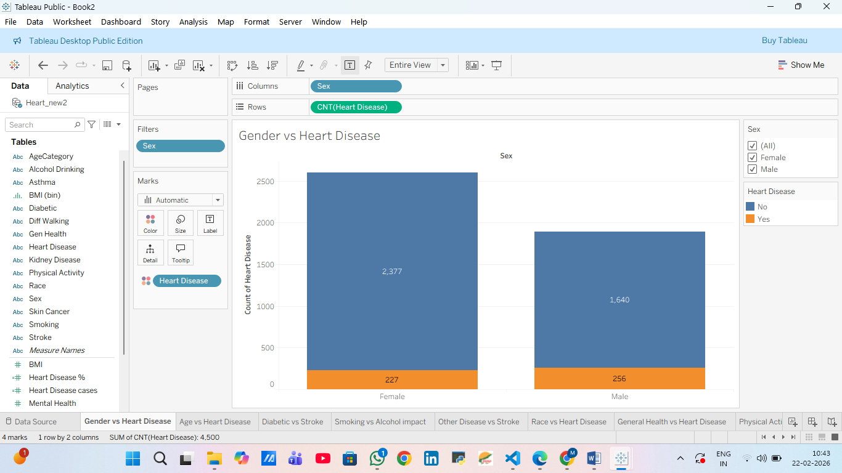
2.DONUT CHART
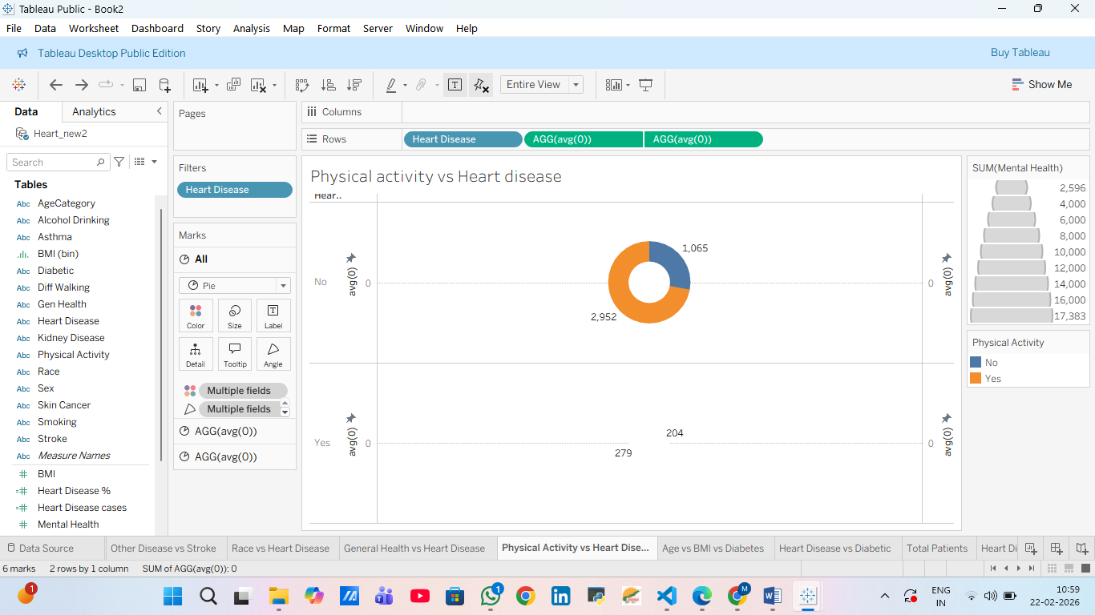

3.TREE MAP CHART
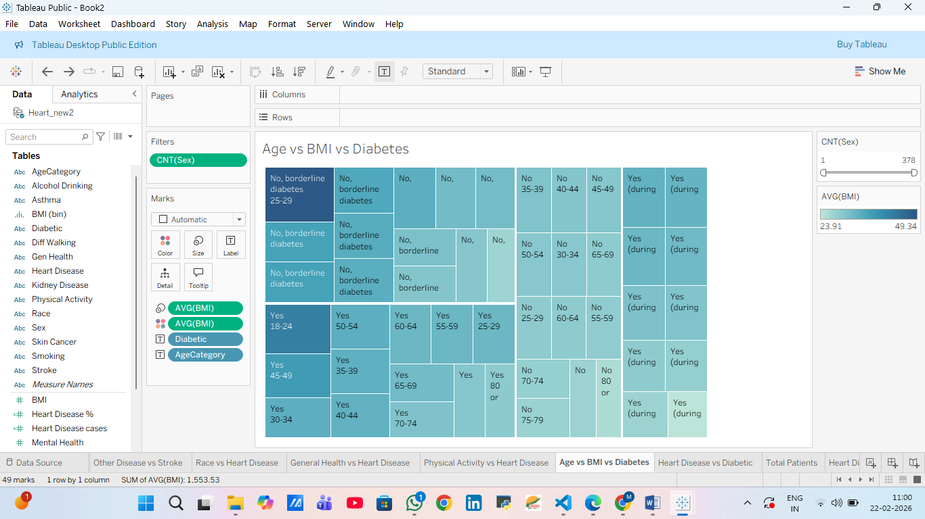

4.BUBBLE CHART
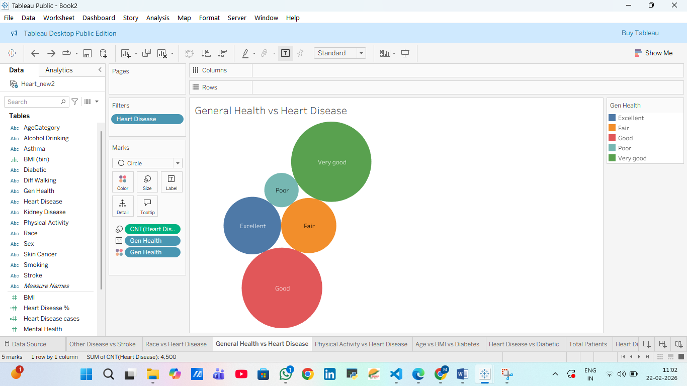

5.CIRCLE CHART
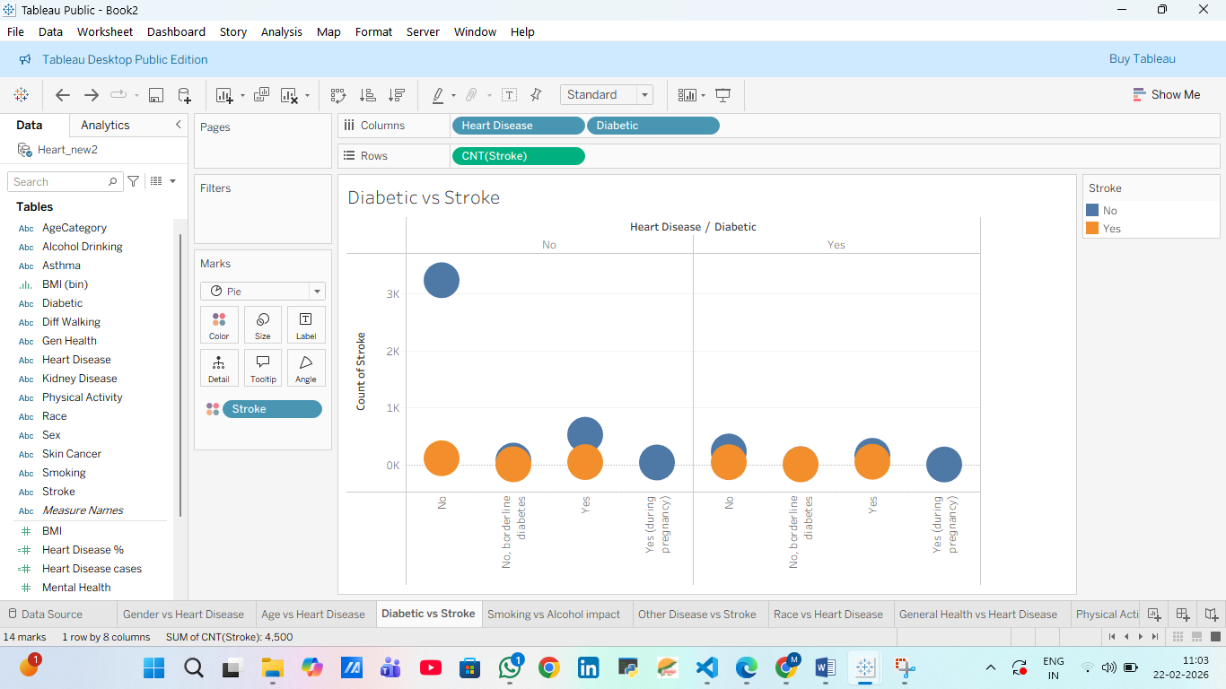
6.LINE AREA CHART
